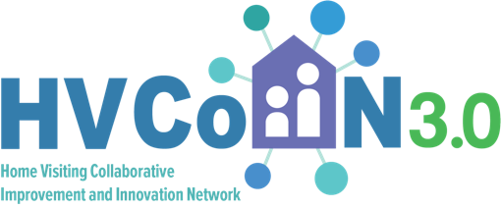

Tips and Scripts to Support Follow-up with Primary Care

Use a checklist to identify when follow-up with primary care provider is appropriate
A short list used after each WCV when talking with family: ​
☐ Developmental concern ​
☐ Missed immunizations ​
☐ Screening concern ​
☐ Social need ​
☐ PCP unaware of family participating in home visiting.

Sample message / script to PCP when follow-up is needed
“Hello, this is [Name], a home visitor with [Program]. I’m reaching out after a recent home visit with [Child] and their family, who are enrolled in home visiting and recently attended a well-child visit with your practice.​ The family identified [family priority] as a focus area after the visit, and we wanted to connect to support coordination and reinforce next steps as appropriate. We’re happy to align our home visiting support with your care plan and the family’s goals.”

Identify a process for follow-up communication
Instead of reaching out after every well-child visit:
• One staff member sends follow-ups
• Once per week
• For all WCVs that met follow up criteria

Sample script when you get past the front desk
Hi, my name is [Name]. I’m a home visitor working alongside the family of [child’s first name]. I’m calling to support follow-up from a recent visit and to help reinforce the care plan you shared. My role is to support the family between visits and help ensure next steps are clear and easy to follow. We really value working I partnership with the primary care team supporting families we serve and look forward to connecting about [insert opportunities for follow up from visit] What might be the best way to follow up with the provider? What logistical next steps might need to happen?

Sample script for family-supported handoff
Script: “You’ve been really thoughtful about following through after the appointment. One option is to send a message through MyChart to share how you’ve reflected on the recommendations and to confirm next steps or to raise any question you have. Having this in MyChart helps keep the plan clear and makes scheduling easier going forward. I can help you draft that communication if helpful.”​
​
Sample communication: ​
“Hi [Provider Name],​
I wanted to follow up after our most recent appointment. I’ve had time to process the recommendations you shared and talked them through with my home visitor. I feel confident continuing to support [child’s name]’s development and wanted to confirm a few follow-up details so we’re aligned moving forward.​
​
Could you please clarify:​
- How often [child’s name] should be seen for well-child visits​
- Whether our recent visit (when [child’s name] was on antibiotics) counted as a well-child visit or a sick visit​
- If future visits can address both routine care and any concerns at the same appointment​
​
Thank you for your continued support of [child’s name]’s care.”

