Readying Your Team Worksheet (Part 1)
Worksheet objective: Build a diverse team (diversity of expertise, perspectives, experiences, roles, disciplines, personal identities) and begin to form trusting relationships.
Why this is important: To advance caregiver-child interaction with an intention towards health equity, improvement teams will need to have a solid foundation. Building a diverse team can help check bias and assumptions and contributes to improved decision-making and innovation. Spending time getting to know each other will help build trust and create space for vulnerability and honest conversation. Nurturing team connections and supporting staff through their individual health equity journey is critical.
Instructions: Complete this worksheet as a team and upload your completed worksheet to your team’s Box folder by February 8 (NOTE: you will receive information on how to access your Box folder during the January 18 Pre-work call).
Identifying Team Members
Each local site is expected to assemble a team of individuals with the will and interest to advance early relational health. A team approach enables you to benefit from a variety of skills and experience and implement an actionable plan. As you consider members of your team, aim for diversity, including members that are multidisciplinary, and multicultural, and include people with lived experience, individuals with quality improvement expertise, and where possible individuals with various levels of seniority and decision-making authority within an organization or program. Suggested team members for LIAs (Local implementing agencies) include:
- Your agency lead (e.g., Home Visiting Program Director, CEO, Agency CQI (Continuous Quality Improvement) Lead)
- Supervisors
- Home visitors
- Data managers
- Families served by home visiting
- Community partners (e.g., Cultural leaders, primary care/FHQHC, early intervention and behavioral health agencies that you refer families to)
List the members of your team in the table below. As you identify and recruit team members to join you on this journey, consider the reflection questions below the table.
Team Member | Role | Expertise/Perspective

How does your CQI team reflect the communities and families that you serve?

Which community partners do you need to engage in your CQI team? Are those partners representative of the communities you serve and understanding of their strengths and needs?​

How have those with lived experience been meaningfully involved and represented in your team?

Who else needs to be recruited or invited to join your team? Who will approach them? How? When?

Team-Building Activities
In your initial meetings, spend time getting to know each other. Below are two examples of activities that teams can do together as they begin this work.
- Exploring Our Own Early Relationships
Objectives:
- To get to know each other as team members, so participants are more comfortable with each other through this improvement journey.
- To point out the experiences and resources you have in your team.
Time:
15 minutes (more time may be needed depending on the size of the group)

Directions:
Ask participants to share:
- Please share one early relationship that had a positive impact on your wellbeing. What interactions do you remember most?
- How might this early relationship impact the way that you work with families today?
- What is one relationship-based attribute that you bring to the team? (e.g., good listener, caring, reliable, etc.)
Debrief individually:
- How did you feel discussing your experiences with your teammates?
- Were there any surprises?
- What did you learn from this exercise?
- How can you apply the learning to your work together?
Reflect on the following learning points:
- Our work moving forward is about relationships and feeling safe exploring the things that get in the way of recognizing, discussing, and moving forward healthy, nurturing daily interactions with families and within our team.
- When we look below the surface of one another's life experiences, we gain a deeper understanding of each other and seek to understand similarities and differences as strengths that make our teams stronger.

- Offsetting Assumptions through an Strengths-Based Approach
Objectives:
- To talk candidly as team members, to examine and shift assumptions or biases, so participants are more comfortable being open with each other through this improvement journey and in addressing possible biases that arise while supporting caregiver child interaction
- To point out who is in your home visiting program community, what families might need to be most successful in their relationships and how we can best meet those needs.
Time:
15 minutes (more time may be needed depending on the size of the group)

Directions:
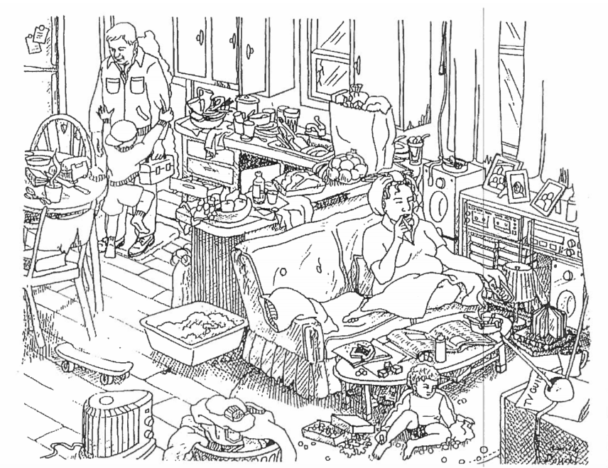
Ask participants to:
- Take a few moments of reflection and look at the image.
- Share all of the positive things they see in this image, describing these strengths with a focus on caregiver child interaction. Consider going round robin allowing each person to identify 1-2 positive or strength-based aspects they see.
- Please share one example of how an assumption or bias could get in the way of how they enter their work to promote caregiver child interaction with this example family.
- Discuss how an asset-based approach could help strengthen partnerships with families.
- What is one asset-based attribute that you bring to the team? (e.g., good listener, caring, reliable, etc.)
Debrief individually:
- How did you feel discussing your experiences with your teammates?
- Were there any surprises?
- What did you learn from this exercise?
- How can you apply the learning to your work together and with families to support caregiver child interaction?
Reflect on the following learning points:
- The work of creating an equitable learning community begins with self-reflection around our own biases that may arise. To be human is to have biases. Biases are not inherently good or bad. Biases are mental shortcuts; they help us think quickly about things, make decisions, and respond to our environments. Biases can become negative, however, if we are not aware of how they direct us to respond to groups of people based on socialized concepts such as race, class, and gender. When interacting with families, especially families who may show up differently than we do, it is important to maintain an strength-based lens by focusing on families strengths.
- When we observe objectively and become attuned to using an asset-based approach to address assumptions, we can more deeply connect with families and partner towards openly discussing healthy relationships, celebrating strengths and discussing areas of challenge—together. This is true of our internal team relationships as well. Using strengths to build team connections and openly discuss bias or assumptions in our work can lead to deeper connections and continued growth toward sustaining a welcoming and validating environment.

Rock D, Grant H. Why diverse teams are smarter. Harvard Business Review. November 4, 2016. Accessed 12/9/2022. https://hbr.org/2016/11/why-diverse-teams-are-smarter This project is supported by the Health Resources and Services Administration (HRSA) of the U.S. Department of Health and Human Services (HHS) under grant number UF4MC26525, Home Visiting Collaborative Improvement and Innovation Network (HV CoIIN). This information or content and conclusions are those of the author and should not be construed as the official position or policy of, nor should any endorsements be inferred by HRSA, HHS or the U.S. Government.

