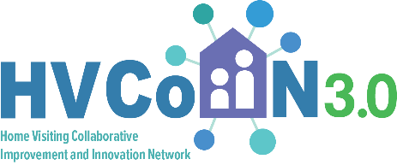

PDSA Cycle
Details

PDSA Cycle #: PD2.SD2.C2.Example 2.WCV Family Planner
Primary Driver 2: Knowledgeable, supported caregivers

Secondary Driver: After well child visit appointments

Change idea: Support families to use parent-held and maintained well child visit and screening records

Change to test: Use “Well Visit Planner” app to track WCVs and development

Prediction
If we… families download and use the free Well Visit Planner app on their phone

It will result in… families having a secure way to keep track of well child visits, their child’s development and access to important health information and resources.

Plan
What: Two parent educators, RW and SG, will each select one family to download and use the Well Visit Planner app to help these families track their child’s well visits, development and have free access to important health information and resources.
What idea are you testing in this PDSA cycle? (script to introduce depression screening)

Who: Two home visitors, RW and SG
With Whom: Two selected families

Start Date: 3/1/2026
End Date: 3/31/2026

Where: At home visits

Task or Tools required to set up: Information about the Well Visit Planner app (www.wellvisitplanner.org)
What tasks will you need to complete before testing the change? (e.g. draft script and review with team)

Plan for Collection of Data
What: Get feedback from the family about the usefulness of the app and how they used it during and after the WCV. Ask whether they shared or discussed this with the doctor at the WCV.
What data will you collect? Include both qualitative and quantitative data
Who: Two home visitors
Who will collect this data?

With Whom: Two families
Who will you collect this data from?

Start Date: 3/1/2026
End Date: 3/31/2026

Where: At home visit or over the phone
Where will you collect the data from?

☐Please check the checkbox below if a parent contributed to the development, testing or adaptation of this change. Parent contribution could involve suggesting the change idea, helping to plan or execute the PDSA, studying the results or planning next steps.

Do: The two home visitors talked to one family each about the Well Visit Planner. This was explained to families as a way to support a better partnership between them and their child’s health care providers. Both families chose to download the app and try using it.
Was the test carried out as planned? What did you observe that wasn’t part of the plan?

Study: Both families report really liking the app and said how easy it is to navigate. This helped them keep track of well visits for all of their children. The liked the Guide feature within the app that helped them to prioritize their visit and provided them with tips. Both families have shared that they are using the app with their child’s pediatrician. One provider had a very positive response and looked at the app together with the parents.
What did the data tell you? (include here the data that answers the question or prediction you sought to answer with this PDSA) What surprised you?

Act: Adapt. We will try sharing this resource with a few more families. We think some families will really like that this is an easy way to use technology to support their WCVs.
You may select to adapt, adopt, or abandon this PDSA Cycle

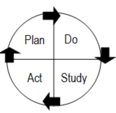
RAMP
Short-term aim:
Change being tested:
Indicator (how will you know if the change is an improvement?):

Cycle #2* | Cycle #3 | Cycle #4
What:  Who (population):  When:  Prediction:  If we…  It will result in….  Results:  Act:  - Adapt:  - Abandon  - Adopt | What:  Who (population):  When:  Prediction:  If we…  It will result in….  Results:  Act:  - Adapt:  - Abandon  - Adopt | What:  Who (population):  When:  Prediction:  If we…  It will result in….  Results:  Act:  - Adapt:  - Abandon  - Adopt
*Ramps of PDSA cycles are provided as examples to show how teams tested and adapted change ideas over time and different conditions to build their confidence that a change was effective. Additional teams looking to test these ideas should adapt the plans for each cycle to both their local contexts and what is learned in each PDSA cycle that is run.

